Navigate Appointment Instructions

1. **To participate in a WebEx or one-on-one In-Person learning assistance session, you must schedule with a learning assistant at least 24 hours in advance through Navigate.**  To access Navigate appointments, first log into your pirate portal and select “Navigate-Student.”

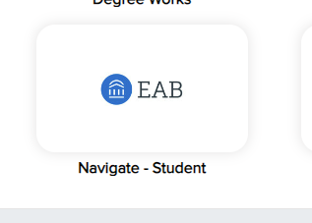

1. You will be taken to the following login screen:

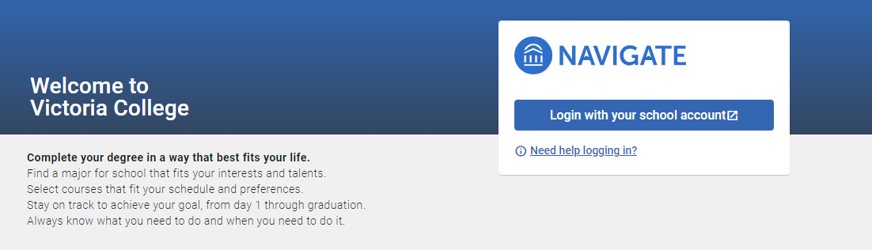

Choose “Login with your school account.”

1. You will then enter your Navigate dashboard. Select “Appointments.”

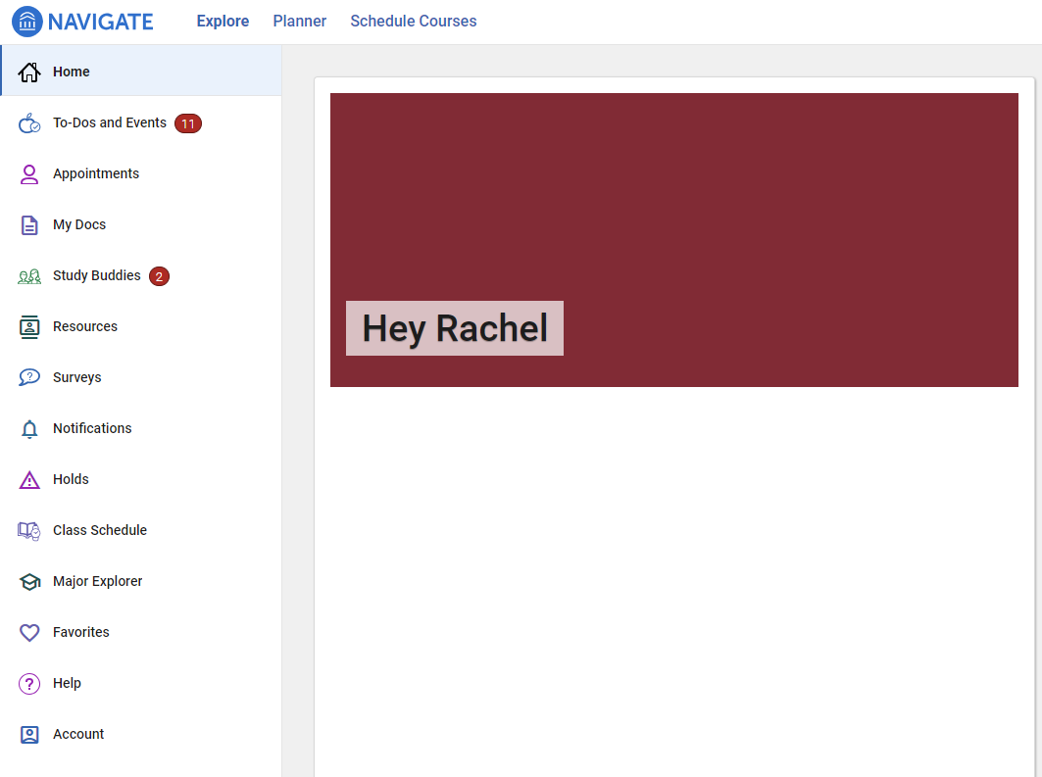

1. On the next screen, choose “Schedule an Appointment.”

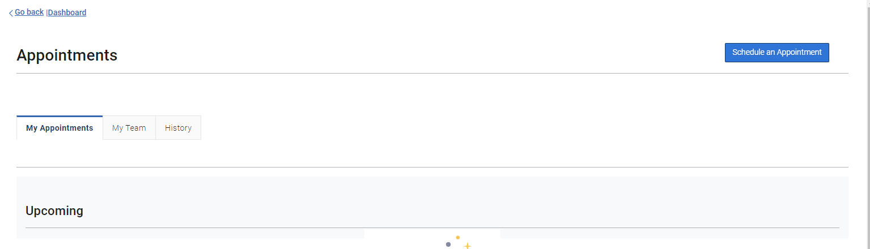

1. On the next screen, for the prompt “What type of appointment would you like to schedule?” choose **Learning Labs**. For the prompt “Service,” choose the subject or skill area for which you would like assistance. For the prompt “Pick a Date,” choose a date for which you’d like to attend. 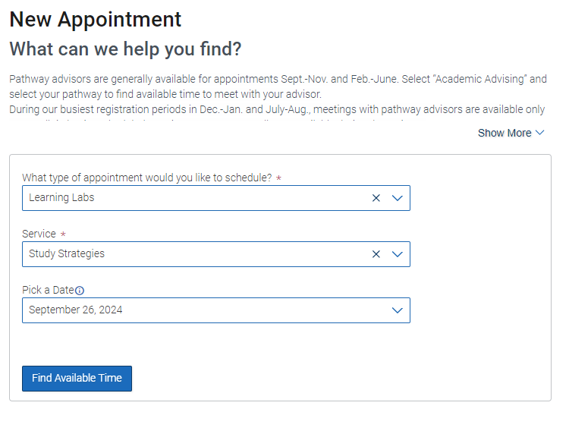

When you choose a date, you will also be able to toggle across other dates to see alternate availabilities. Click on each date to check what appointments are availability.

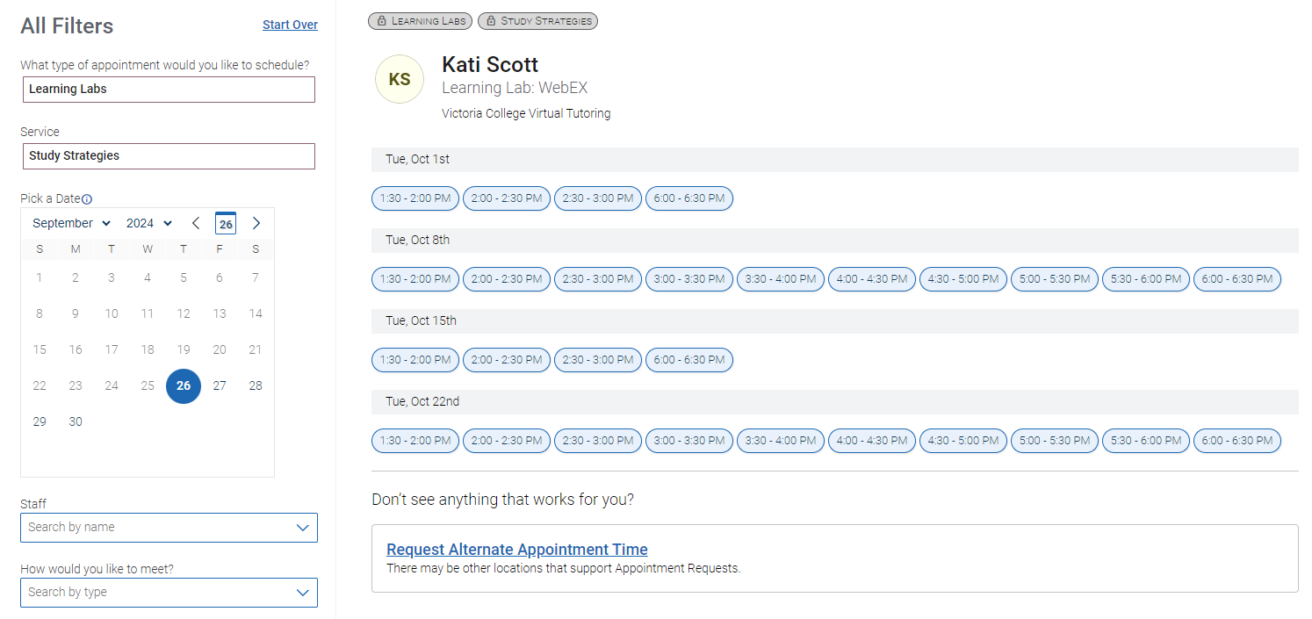

1. Once you’ve selected your date and time, you will be able to view the appointment confirmation screen. This screen will provide you with important details about your session and how to prepare for it. You will also be able to see the learning assistant’s WebEx room address if the appointment is going to be virtual. 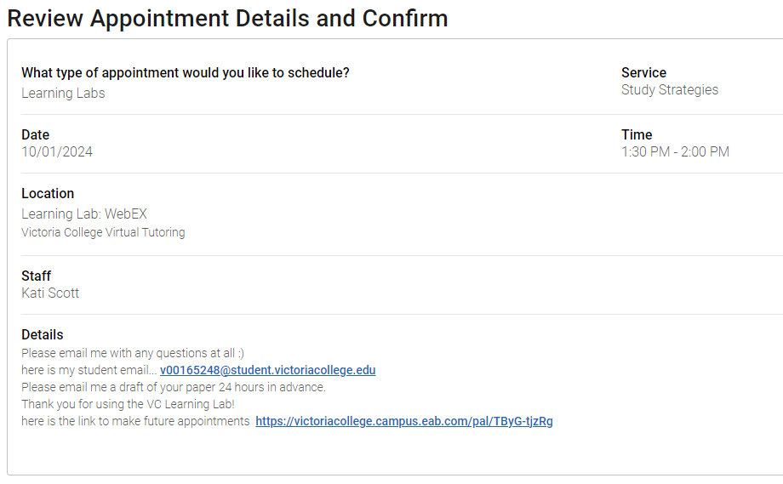

Scroll down to the bottom of your screen to select how you would like to meet – virtual or in-person. You may also add your phone number for an automated text message reminder for your session.

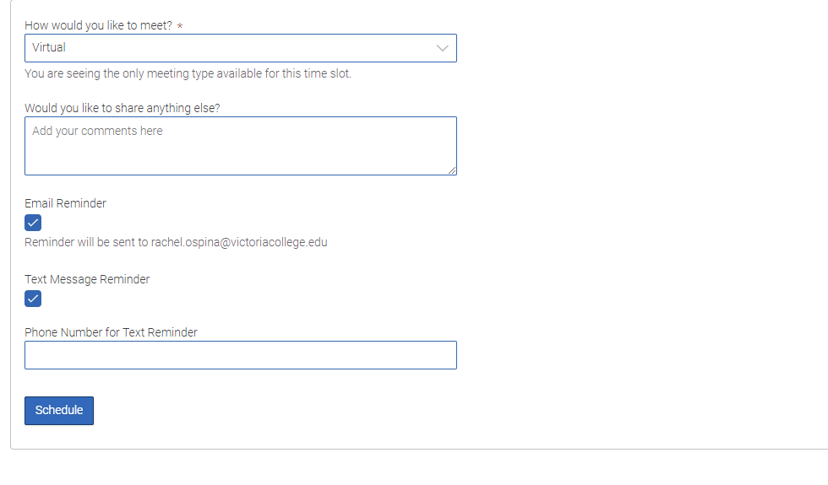

1. After selecting “Schedule,” you will receive a confirmation screen.

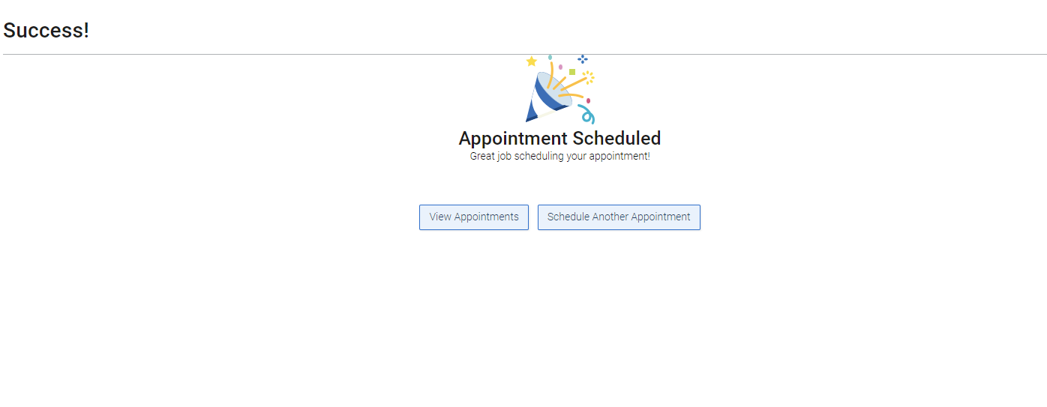

You will also receive an email to your student email account.

If you are attending for assistance with a written paper, please submit your document to the learning assistant at least 24 hours in advance by sending it to his/her email so that he/she can assist you during your session. If you are attending for another reason (not a written paper), please be prepared with your book, assignment, and any other materials that may be needed.

To attend your session virtually, simply click on the WebEx room link in your appointment confirmation email.